LPR LICENSE PLATE ENTRY REQUIREMENTS

Passenger Plates:
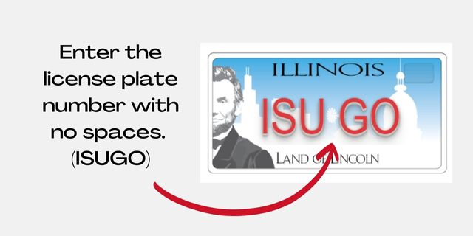

B Truck Plates: Do not enter the “B” on truck plates.
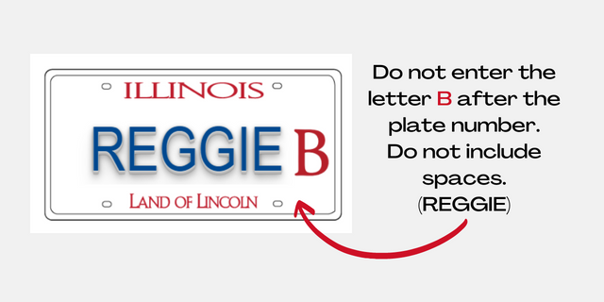
Specialty Plates:
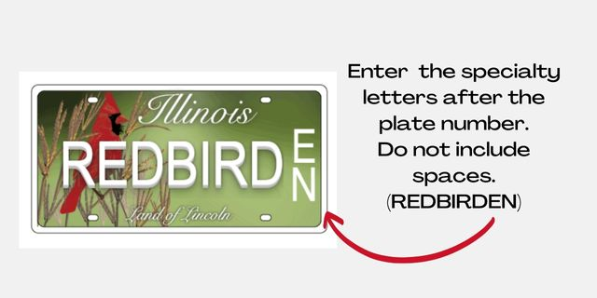

Motorcycle Plates:
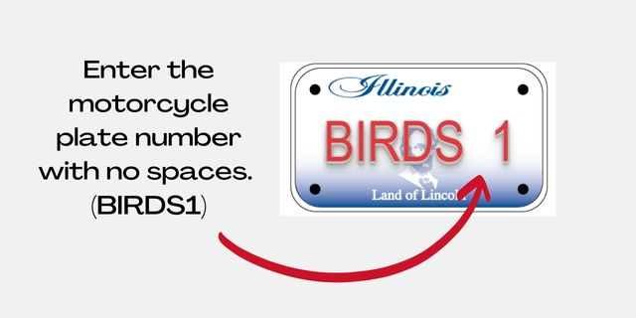
Special Character Plates: Do not enter the special character. This plate would be entered as “ICSULB”.
